Resort topic functionality: The ability to create and manage reservations for specific dates and sizes of rooms, along with the option of canceling said appointments, is going to be the backbone of the project. We’ll also be looking into managing different sorts of accommodations per room (different views to the outside areas, different types of beds, different types of sizes for each room, etc). In addition, we will be working on a way to compile each booking change in a single, easy to access report panel for staff to keep tabs on. Finally, we will be working on specific scenarios that may be uncommon such as being sold out of rooms.

Group Members: Brandon Baker, Todd Bauer, Chase Canales, Jose Silvestre-Bautista, Gerardo Ortiz, Cristian Mendoza

Group Manager: Cristian Mendoza

Group name: import team_name

Meeting schedule: Tuesdays after class (around 3:00 pm)

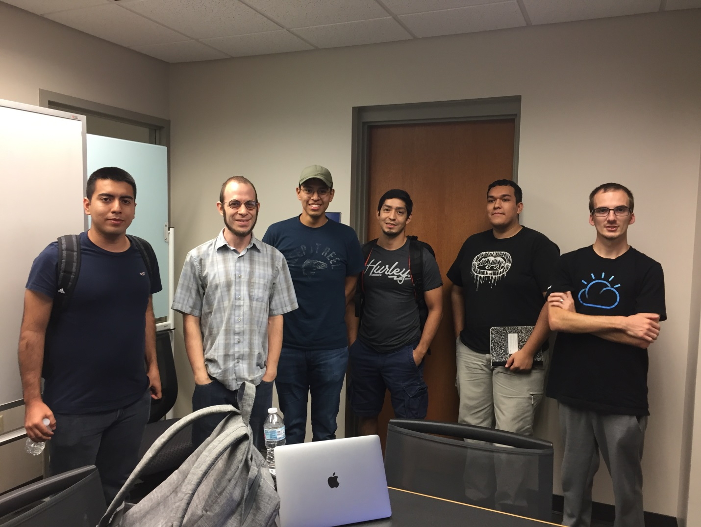

The six of us (with Chase taking the picture) with our mentor, Carlos